國立臺北教育大學學生宿舍冷氣儲值卡使用須知
National Taipei University of Education Regulations for the Use of Dorm Air-Conditioner IC Cards
- 目的：
- Objective:
為有效節能減碳及增進用電效率，宿舍寢室及交誼廳採使用者付費原則辦理。
These guidelines have been set for effective energy conservation and carbon reduction; use of air-conditioners in dormitory rooms and common halls will be paid for by the users of the facilities.
- 使用方法
- Methods of use
  - 為節省能源，本校依據行政院訂頒「政府機關及學校全面節能減碳措施」之規定，公家機關室內溫度須達攝氏26度以上方能啟動。
- To conserve energy and reduce carbon emissions, the university is adhering to the Executive Yuan’s “Comprehensive Measures for Energy Conservation and Carbon Reduction by Government Agencies and Schools,” which requires public offices to have an indoor temperature of 26 degrees Celsius for air-conditioners to be turned on.
  - 宿舍冷氣之使用，須以儲值式IC卡 (以下簡稱IC卡 ) 作為電源開關控制啟動，並以卡內之儲值金額支付冷氣費用，卡片插入時會顯示卡內餘額，亦可顯示電表度數，不使用冷氣時，請務必將儲值卡移除。
- Students should have IC cards (hereafter called IC card) with stored cash value to be able to use the air-conditioners in the dormitory; the cash value stored in the IC card will be used to turn the air-conditioners on and off as well as to pay for their use. When the card is put into the slot, it will show the available balance, as well as the amount of electricity used from the meter. When not using the air-conditioner, make sure that the IC card is removed from the slot.
  - 每學期開宿當日即可辦理IC卡購買與儲值，IC卡片區分學年及臨時二種使用：
- IC cards can be bought and cash value can be stored on the day one moves into the dormitory each semester. They are divided into annual and temporary cards.
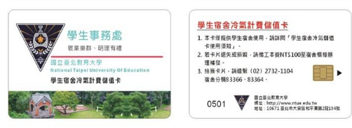
    - 學年卡；屬買斷制，提供住宿學生住宿期間使用。
- Annual card: outright purchased; provided for the use of dorm students within the period of residency.
      - 個人卡：視個人需要可自行購買。
Individual card: can be purchased individually according to personal need.
      - 寢室卡：視寢室需要可共用購買。
Room card: can be jointly purchased if needed in the dorm room.
    - 臨時卡：屬抵押制，提供寒、暑假校內、外團隊短期使用。
- Temporary card: provided with deposit for short-term use during summer and winter breaks by groups from outside or within the school.
- 繳費儲值
- Payment for value added
  - 請於上班日上午9時至下午16時至本校行政大樓2樓總務處出納組自動繳費機繳費，憑繳費單據至宿舍櫃台領卡或儲值，領取新卡時，請先自行測試，如卡片失效或無法讀取，請三天內(不含假日)至宿舍櫃台更換，否則視同個人保管不當，不予處理。
- Please make payments at the automated payment machine in the Division of Cashier of the Office of General Affairs from 9 am – 4 pm on business days. Bring the receipt to the dorm reception desk to obtain the IC card or to add value into it. When obtaining a new IC card, please test it. If the card is invalid or cannot be read, have it changed at the dorm reception desk within 3 days (not including weekends and holidays) or said issue will be considered as mismanagement of personal property and will not be handled.
  - 收費基準由本組參照臺灣電力公司標準電價簽呈請校長核定，目前本校宿舍每度電收費3.8元；儲值卡額度用罄，應自行至自動繳費服務系統繳費，再持收據辦理儲值卡加值。
- The fees structure was set by the division based on the standard power charges of the Taiwan Power Corporation and has been approved by the university president. Presently, the university dorm charges NT$3.8 per kilowatt. When the value added in the IC card is used up, students should proceed to add to the balance through the automated payment system. Then they should bring the receipt to process the amount to be added to the IC card.
  - IC卡每張工本費新台幣100元，此卡不回收，另工本費不得轉為儲值金額使用；儲值金額為新台幣300元及新台幣500元二種。
- Each IC card costs NT$100 and is non-returnable. The basic cost cannot be counted as value added; students can put either NT$300 or NT$500 on their IC cards.
  - IC卡於學期結束後若不再使用，可於期末封舍後七日內至宿舍櫃台查驗卡片剩餘金額，消除卡片剩餘金額後，於每學期結束後統一退款至歸還持卡人之郵局帳戶，寢室卡亦同。
- If IC card will not be used anymore after the end of the semester, students must go to the dorm reception desk within seven days after the dorm is closed off for the semester to check the remaining value in the card. After the balance is removed from the card, the amount will be refunded at the end of every semester to the cardholder’s bank account with the post office. The same applies to room IC cards.
- 注意事項
- Reminders
  - 請勿任意插入其他卡片，以免讀卡機受損或儲值金額損失。
- Do not put in other cards to avoid damage to the card reader or loss of added value.
  - 本卡請勿折損或接近高溫，若遺失或損毁，恕無法掛失或補發。
- Do not fold the IC card or expose it to high temperatures. Lost or damaged cards cannot be reported as such and will not be replaced.
  - 冷氣關閉後須等冷氣機完全停止運轉才可移出卡片，冷氣關閉後須等三分鐘後方可再度開啟 請同學隨時檢查寢室內冷氣電錶或IC卡機，如有故障可至宿舍櫃台填寫修繕單。
- When the air-conditioner is turned off, wait until it stops completely before pulling out the IC card. Wait for three minutes after it is turned off to turn it on again. Have dorm room residents regularly check the meter of the air-conditioner and the IC card reader in their room; report any anomalies to the dorm reception desk and fill out a repair request form.
  - 各寢室冷氣設備如有人為因素或自行拆卸計費系統以致損壞，除依宿舍管理辦法處理外，應負擔設施損害賠償；另IC卡機及電錶裝置為電力設備，嚴禁拆卸、更動、打開電錶或IC卡機蓋，本組將不定期由寢室外部電表查驗寢室用電度數。
- If the air-conditioner in the dorm room is damaged due to human causes or dismantlement of the payment system, the person responsible should pay for the damage as well as receive punishment in accordance with the dorm management guidelines. In addition, the IC card reader and electric meter are both power equipment. Dismantlement, moving, and opening of the power meter and IC card reader are strictly prohibited. The division will conduct random checks on the power meter to check the amount of electricity used in the room.
  - 本卡係依用電量計費，溫度設定越低，冷氣用電量越高，則扣款金額越多，請節約使用。
- The card charges according to the amount of electricity used. Therefore, the lower the temperature is set, the more money is deducted from the card. Please conserve energy.
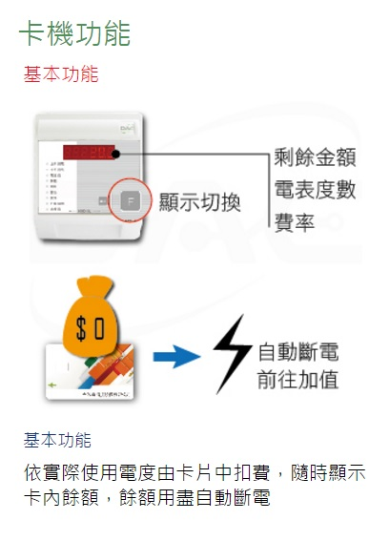

學務處生輔組製
Made by the
Division of Daily Life Guidance
Office of Student Affairs

Top to bottom top to bottom:
Card reader function Automatic power cut
Basic function Please add value
Display change Basic function
Balance Deduction is made according to actual kilowatt
Electric meter reading use. Card balance is displayed here. Power is cut when
Rate balance is used up

